WEEK 2 LAB EXERCISE

**INTRODUCTION TO PROBLEM SOLVING**

NAME: MUHAMMAD AKMAL BIN ABDUL

MATRIX. NUMBER: B032510270

DATE OF SUBMISSION: 16/10/2025

LECTURER NAME: MR. SAFWAN ABD RAZAK

# QUESTION 1

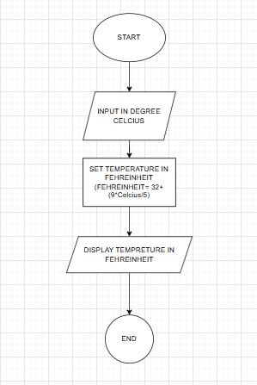

PSEUDO CODE Q1  
  
1.0 Start  
2.0 Display enter temperature in degree Celsius

3.0 Set Fahrenheit = 32 + (9*Celcius /5))

4.0 Display Temperature in Fahrenheit is Fahrenheit

5.0 End

# QUESTION 2

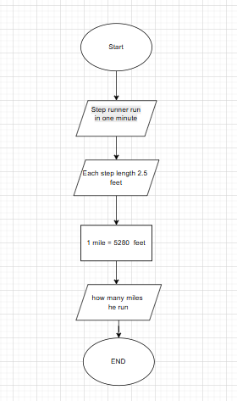

Pseudo Code Q2  
  
1.0 Start  
2.0 Step runner run in one minute   
3.0 Each step length 2.5 feet  
4.0 Set Mile run 5280 feet  
5.0 Calculate how many miles run  
6.0 End

# QUESTION 3

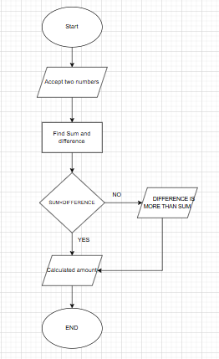

Pseudo Code Q3  
  
1.0 Start  
2.0 Accepted two Number  
3.0 Find Sum and difference   
4.0 Compare sum and difference   
5.0 Determine which amount is more than the others  
6.0 Calculated amount for result   
7.0 End

# LAB 2 GIT SCREENSHOT